Installation Guide

Autodiscipline

Version 1.1 | 19 July 2022

Table of Contents

1 Introduction 3

1.1 Purpose 3

1.2 Getting Started 3

2 Installation Manual 4

2.1 Pre-requisites 4

2.2 Installation Procedure 5

3 Additional Information 6

3.1 Contact Information 6

# Introduction

## Purpose

This document covers the installation of software prescribed within the MonAppli personal organisation product package - Autodiscipline

Read this guide before running installing Autodiscipline.

## Getting Started

For small implementations including developer workstations and testing environments, Autodiscipline can be installed on a single computer. The current version of the app does not support installation on mobile devices. Autodiscipline can be broken down into two logical components with a .zip file being used to install a new instance of Autodiscipline.

The two logical components are:

* Autodiscipline.exe application
* Supporting file system for logs and data

The installation guide should be used whenever possible, to guide you through the installation process.

Please contact [monappli@outlook.com](mailto:monappli@outlook.com) for assistance or to report any discrepancies between this document and the product.

# Installation Manual

The main components that are described in this chapter include the following:

* Prerequisites
* Install procedure
* Rollback or Uninstall procedure

## Prerequisites

Autodiscipline can be installed on the following Microsoft operating systems:

* Windows 7 (32/64-bit, Home Premium and higher) SP1+
* Windows 8 (32/64-bit, Professional and higher)
* Windows 10 and higher

**Important**

The current version of Autodiscipline is not supported by Linux, Android or Apple OS.

**Hardware**

We recommend the following hardware requirements:

* Processor: 11th Gen Intel® Core™ i5-1135G7 (8 MB cache, 4 cores, 8 threads, up to 4.20 GHz Turbo) or greater
* 4 GB of RAM
* 1024x768 or greater screen resolution required for advanced operations.

## Installation Procedure

To start the installation process, you must first unzip the **Autodiscipline zip file** which contains the software package.

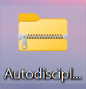

Right click on the zip file and select **“Extract all”.** Select a destination for the extracted files. Once the extraction is completed, a folder will be opened up:

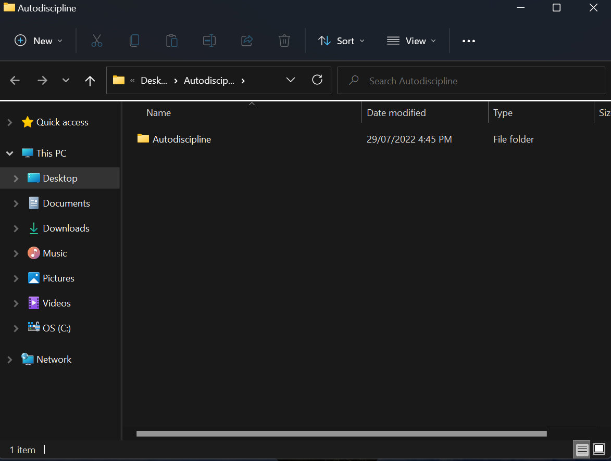

Click on the **“Autodiscipline”** folder to access the following files:

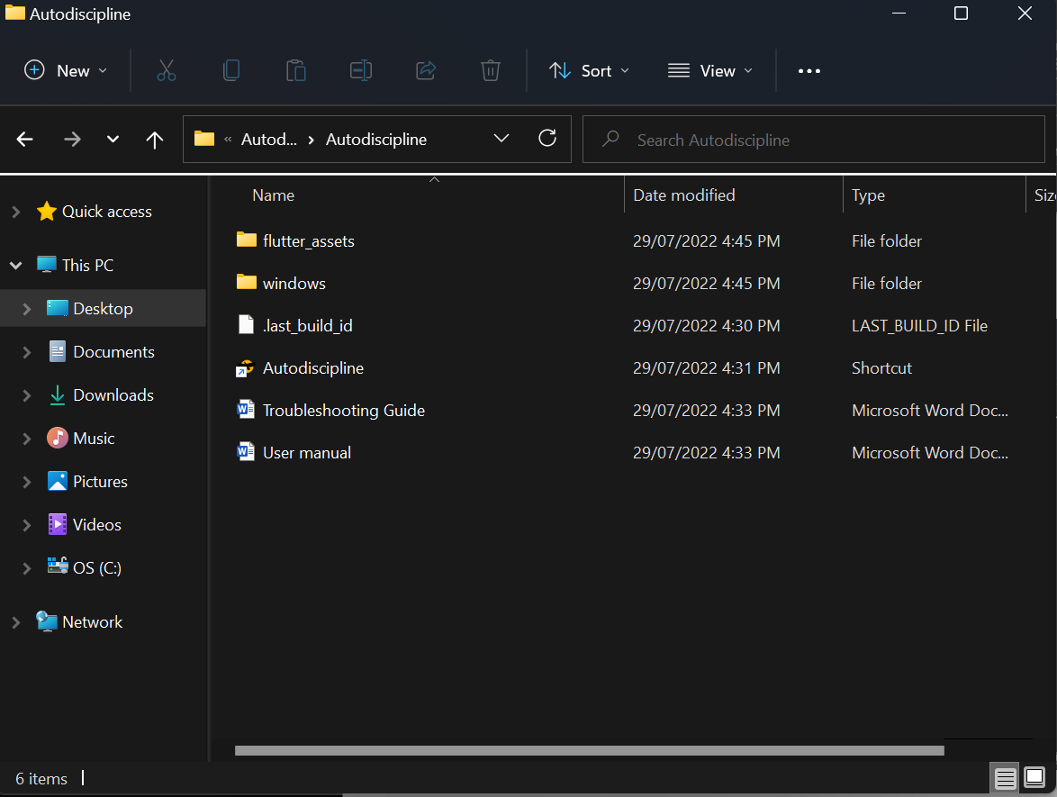

To run the Autodiscipline application, select the shortcut .exe named **“Autodiscipline”.**

# Additional Information

## Contact Information

|  |  |
| --- | --- |
| Title | Description |
| monappli@outlook.com | Contractor Project Manager,  Contractor Technical contact |